

Configuring an RTA1046 with an Engin VoIP account.

Before proceeding you will need to complete the setup of all required hardware components as per the User Guide that came supplied with your Dynalink RTA1046.
- Open up web-browser and type in 192.168.1.1 in the address bar and press <Enter>
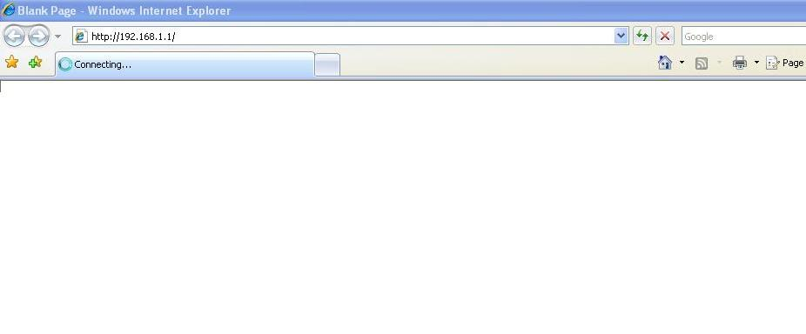
- Now enter in the modem user name password. By default the username is “admin” and the password is “admin” (without quotes).
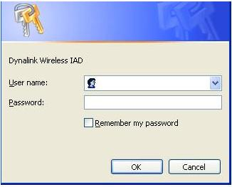

- Click on “Voice” on the top menu bar.

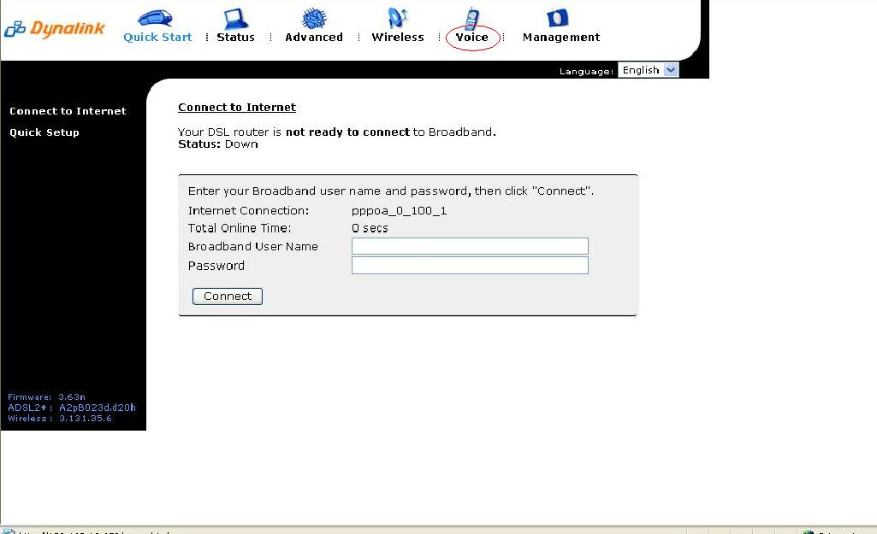

- Now type the following information as required
  - Interface ppp_8_35_1 (from drop down menu)
  - SIP Registrar Address syd.byo.engin.com.au
  - Port 5060
  - SIP Outbound Proxy syd.byo.engin.com.au
  - Port 5060
  - SIP Proxy Server Address syd.byo.engin.com.au
  - Port 5060
  - Phone Number Engin Number
  - Caller Name Engin Number
  - Username Engin Number
  - Password Engin Password
Note: - leave rest of the setting as default settings.

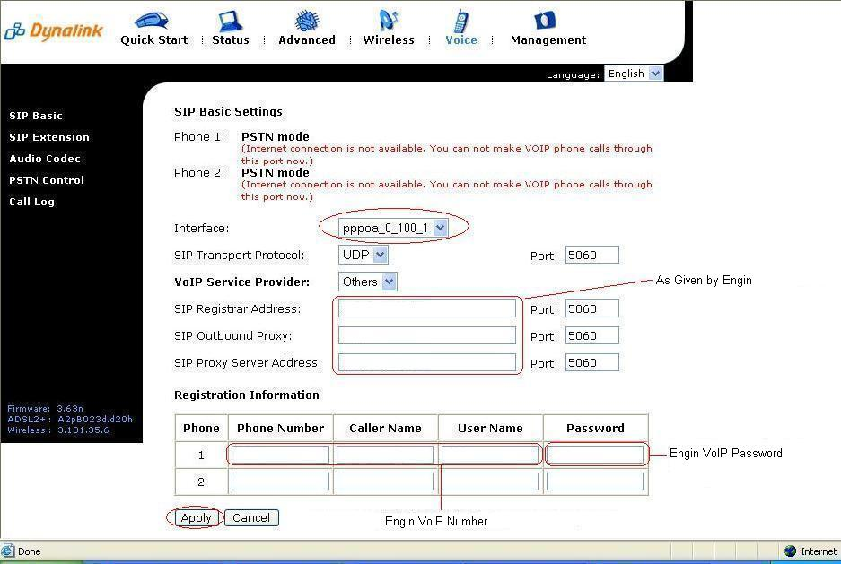

- Now click on “Apply”.

- The RTA1046VW will now attempt to register to Exetel and you will be presented with the following screen.
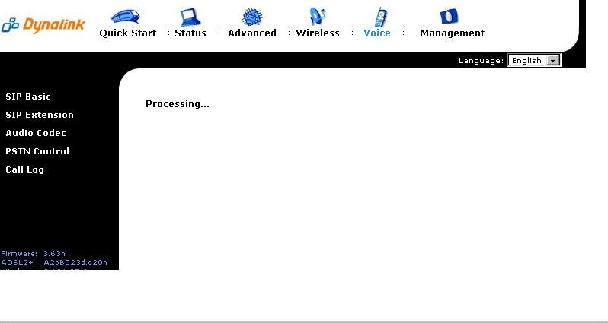

  - You should now be presented with the below screen confirming that your registration details have been successful
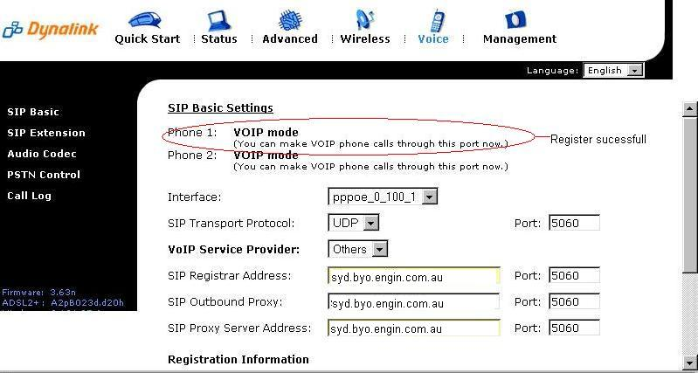

Congratulations, you can now start using a standard telephone handset that is connected to the Dynalink RTA1046VW using Engin’s VoIP service.

Happy chatting!

