
N3G001W
Firmware Upgrade Instructions

- Using your web browser, enter the IP address of your NetComm router into the Address Bar. The default address is http://192.168.123.254.

- Log on using your System Password. The default is admin.

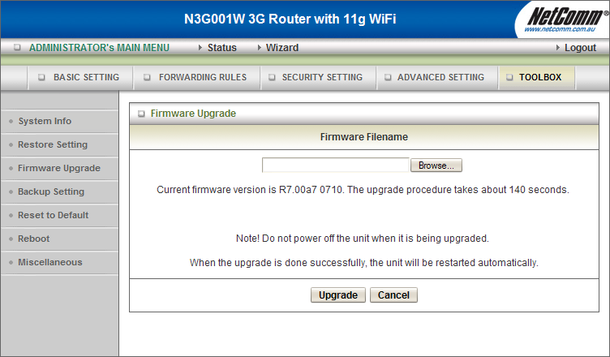
- Click on Advanced Setup at the top.
Click on Toolbox at the top, and then click on Firmware Upgrade on the left.
You will see the following page:

- Use the Browse button to locate the firmware image file.

- After selecting the firmware image file, click Upgrade, and wait for the process to complete.
The process may take approximately 1-2 minutes, after which, the router will reboot.

