NetComm NB9WMAXX Dial Plan Guide

This guide will assist you in creating and managing your Dial Plan rules in the NB9WMAXX.
Dial Plan rules can be used to block certain numbers from being called, or only allow certain numbers to be called, or even force some numbers to be called via your normal telephone (PSTN) line.

Dial-Plane settings:

When creating a Dial-Plan rule, the following options need to be specified:

- Priority
Priority is how the modem checks the rules to see if they apply to your current phone call. When you have dialled your number, the rule with Priority 0 will be the 1st rule that is checked, then the rule with Priority 1, and so on.
When creating Dial-Plan rules, it is best to allow some space in the Priority numbers, as new rules may need to be created in between existing rules.
- Prefix
The Prefix is the number that is dialled which activates the use of the rule. For example, if you are creating a rule to block outgoing calls to a specific mobile number, you would enter the mobile number you would like to block in the Prefix field.
The Prefix field can contain ‘wildcards’, which can represent a group of numbers for 1 digit. For example, to represent the numbers 2,3 and 7 you would type [237]. If you would to represent the numbers of 1 up until 5, you would type [1-5].
Using these, you can specify things such as multiple area codes, or different-sized groups of numbers, such as all mobile numbers beginning with 0412.
- Destination
The Destination specifies where the call will be made from if the rule does not Deny it.
For example, if you would like make a call to a certain number from your normal PSTN telephone line, and NOT your VoIP line, then you would set Destination to ‘pstn’.
- Max Digit
This specifies how many digits are required before the rule will take effect. When managing rules that contain landline phone numbers with Area Codes (eg: 0294242000) or Mobile Numbers, set the Max Digits to 10.
When managing rules that contain landline phone numbers without area codes, set the Max Digits to 8.
- Action
This is where you specify if you want the rule to block the call, or allow the call.

Outgoing Dial-Plan rules:

Below is an example of a set of Outgoing Dial-Plan rules as configured in the NB9WMAXX: -

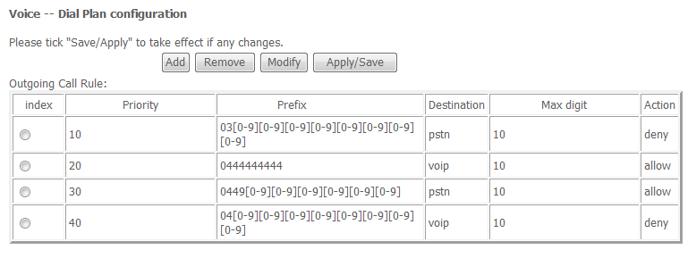

The 1st rule with Priority 10 has a Prefix of: 03[0-9][0-9][0-9][0-9][0-9][0-9][0-9][0-9]
You will also see the Destination set to pstn, the Max Digit as 10 and the Action as deny.
This rule is blocking all outgoing calls to ANY number with an Area Code of 03 (VIC).

The 2nd rule with Priority 20 has a Prefix of: 0444444444
You will also see the Destination set to voip, the Max Digit as 10 and the Action as allow.
This rule is allowing calls to be made to the mobile number of 0444 444 444.
This rule is being used in conjunction with the last rule in the table (with Priority of 40).

The 3rd rule with Priority 30 has a Prefix of: 0449[0-9][0-9][0-9][0-9][0-9][0-9]
You will also see the Destination set to pstn, the Max Digit as 10 and the Action as allow.
This rule is allowing calls to be made to any mobile number which begins with 0449, and is forcing those calls to be made via the PSTN line instead of via VoIP.
This rule is being used in conjunction with the last rule in the table (with Priority of 40).

The 4th rule with Priority 40 has a Prefix of 04[0-9][0-9][0-9][0-9][0-9][0-9][0-9][0-9]
You will also see the Detination set to voip, the Max Digit as 10 and the Action as deny.
This rule is blocking all calls from being made to numbers that begin with 04, and that are 10 digits in length, ie: all Mobile Numbers.
The 2 rules above this rule in the table (with Priority 30 and 40) are ALLOWING calls to certain mobiles to be made, even though this rule is BLOCKING calls to mobiles.
This is because the above 2 rules have a higher Priorirty number, and are checked before the 4th rule.
In this situation, if you wish to add more numbers into the list to allow calls to be made to other mobile numbers, you will need to add them with a higher Priority than 40 (such as 38, 32, etc).

Incoming Dial-Plan rules:

Please Note: Incoming Dial-Plan rules are ONLY for incoming VoIP calls.
Incoming Dial-Plan rules do not affect incoming PSTN calls.

Below is an example of a set of Incoming Dial-Plan rules as configured in the NB9WMAXX: -
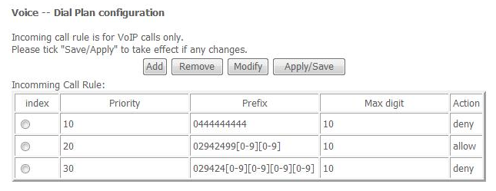

Incoming Dial-Plan rules are exactly the same as outgoing, but without the Destination field.

The 1st rule with Priority 10 has a Prefix of: 0444444444
You will also see the Max Digit as 10 and the Action as deny.
This rule is blocking incoming calls from the mobile number 0444 444 444.

The 2nd rule with Priority 20 has a Prefix of 02942499[0-9][0-9]
You will also see the Max Digit as 10 and the Action as allow.
This rule is allow incoming calls from any number that begins with 02 9424 99.
This rule is being used in conjunction with the last rule in the table (with Priority of 30).

The 3rd rule with Priority 30 has a Prefix of 029424[0-9][0-9][0-9][0-9]
You will also see the Max Digit as 10 and the Action as deny.
This rule is blocking incoming calls from any number that begins with 02 9424.
The 2nd rule in the table (with Priority 20) is ALLOWING incoming calls from numbers that begin with 02 9424 99, because it has a higher Priority than the 3rd rule.
In this situation, if you wanted to allow more numbers that begin with 02 9424, you would put them in with a Priority higher than 30 (such as 29, 23, etc).

