N3G002W WAN failover Guide

The WAN failover feature of the N3G002W is designed to provide a backup 3G Internet connection in case your primary connection should fail. To use this feature, you will need both an Ethernet WAN connection (from an xDSL modem/ISDN/Satellite etc) and a 3G WAN connection.

Please follow these steps to set up WAN failover on your N3G002W.

- Set up a primary (non-3G) WAN connection by following the steps outlined in the Basic Setting > Primary Setup section of the N3G002W User Guide.

- Set up a secondary (3G) WAN connection by following the steps outlined in the Basic Setting > Primary Setup section of the N3G002W User Guide.

- Open your web browser (e.g. Internet Explorer/Firefox/Safari) and navigate to http://192.168.123.254/.

- At the login screen, type in “admin” (without quotes) in the System Password field. Then click on Login.

- Navigate to the Basic Setting > Primary Setup page. Select the Enable checking wired-WAN alive checkbox and enter a public IP address (for example 'www.google.com') into the internet host box. The N3G002W will periodically check that it can connect to this address to determine if the WAN connection is still running.
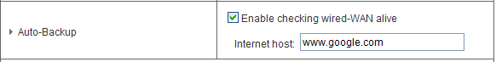

- When your primary (non-3G) WAN connection fails, the N3G002W will automatically failover to the secondary (3G) WAN connection. Please allow up to 2 minutes for this change to occur.
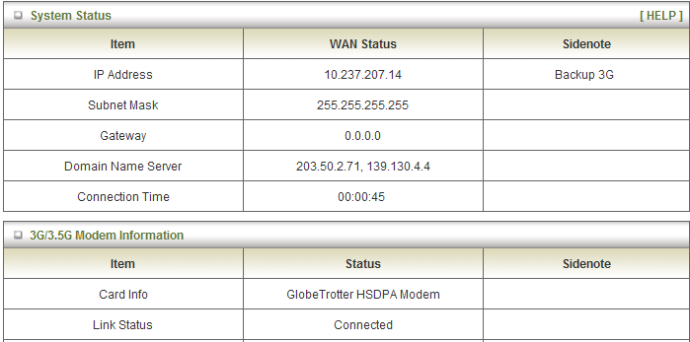

- When your primary (non-3G) WAN connection reconnects, the N3G002W will automatically revert to this connection. Please allow up to 2 minutes for this change to occur.

- To confirm that the process in Step 7 is complete, refresh the status page of the web interface after 1 minute. The WAN connection should appear as shown below:
