

Configuring an RTA1046 with a TPG VoIP account.

Before proceeding you will need to complete the setup of all required hardware components as per the User Guide that came supplied with your Dynalink RTA1046.
- Open up web-browser and type in 192.168.1.1 in the address bar and hit enter
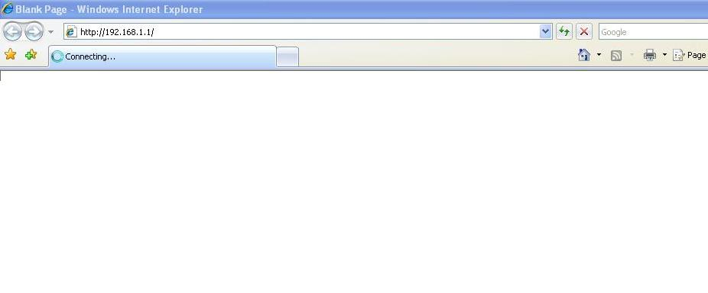
- Now enter in the modem user name password. By default the username is “admin” and the password is “admin” (without quotes).
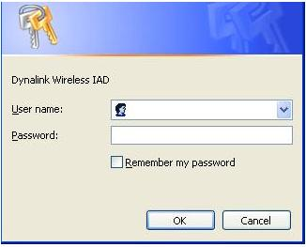

- Click on “Voice” on the top menu bar.

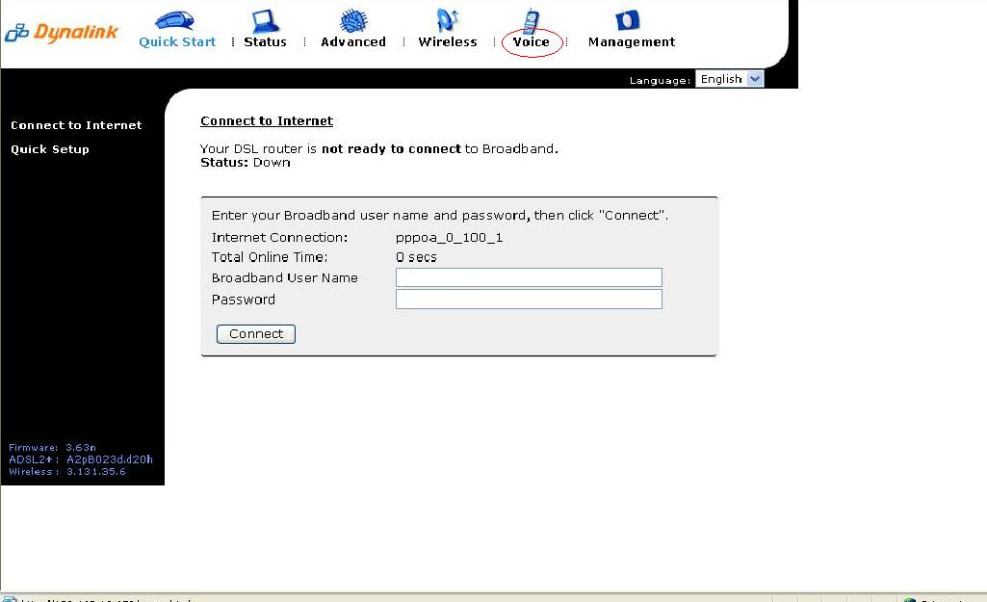

- Now type the following information as required
  - Interface ppp_8_35_1 (from drop down menu)
  - SIP Registrar Address aphone3.tpg.com.au
  - Port 5060
  - SIP Outbound Proxy aphone3.tpg.com.au
  - Port 5060
  - SIP Proxy Server Address aphone3.tpg.com.au
  - Port 5060
  - Phone Number TPG Number (as advised by TPG)
  - Caller Name TPG Number (as advised by TPG)
  - Username TPG Number (as advised by TPG)
  - Password TPG Password (as advised by TPG)
Note: - leave rest of the setting as default settings.
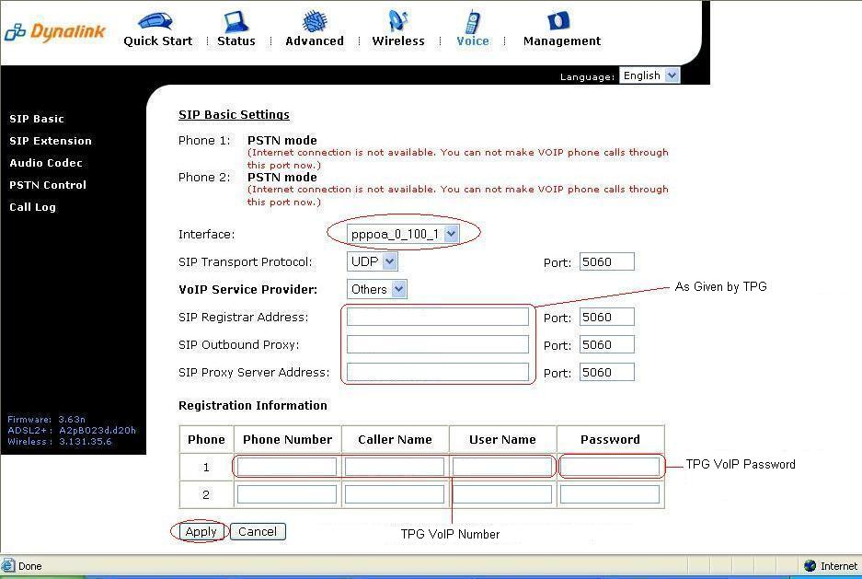

- Now click on “Apply”.

- The RTA1046VW will now attempt to register to Exetel and you will be presented with the following screen.
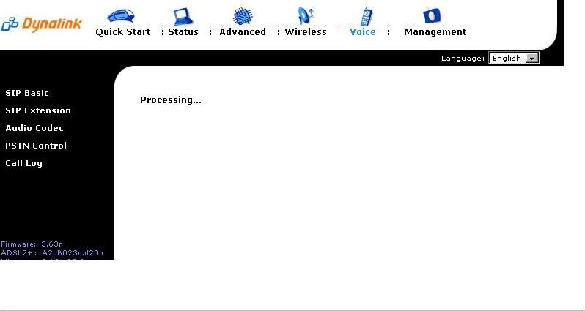

  - You should now be presented with the below screen confirming that your registration details have been successful

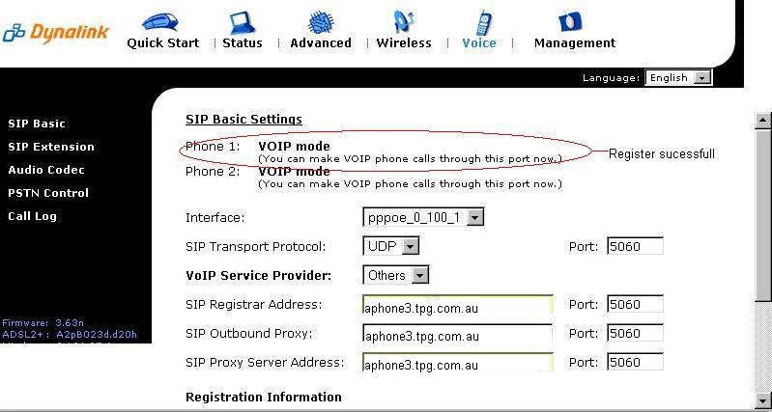

Congratulations, you can now start using a standard telephone handset that is connected to the Dynalink RTA1046VW using TPG’s VoIP service.

Happy chatting!

