N3G005W WAN failover Guide

The WAN failover feature of the N3G005W is designed to provide a backup 3G Internet connection in case your primary connection should fail. To use this feature, you will need both an Ethernet WAN connection (from an xDSL modem/ISDN/Satellite etc) and a 3G WAN connection.

Please follow these steps to set up WAN failover on your N3G005W.

- Open your web browser (e.g. Internet Explorer/Firefox/Safari) and navigate to http://192.168.123.254/.

- At the login screen, type in “admin” (without quotes) in the System Password field. Then click on Login.

- Set up a primary (non-3G) WAN connection by following the steps outlined in the Basic Setting > Primary Setup section of the N3G005W User Guide.

- Set up a secondary (3G) WAN connection by following the steps outlined in the Basic Setting > Primary Setup section of the N3G005W User Guide.

- Navigate to the Basic Setting > Primary Setup page. Select the Enable checking wired-WAN alive checkbox and enter a public IP address (for example 'www.google.com') into the internet host box. The N3G005W will periodically check that it can connect to this address to determine if the WAN connection is still running.

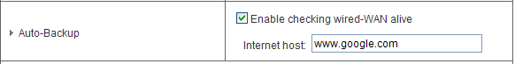

- In Basic Setting > Primary Setup, make sure that the selected WAN Type is your primary (non-3G) WAN connection and click Save. You are now ready to use the internet connection as normal.

- When your primary (non-3G) WAN connection fails, the N3G005W will automatically failover to the secondary (3G) WAN connection. Please allow up to 2 minutes for this change to occur.

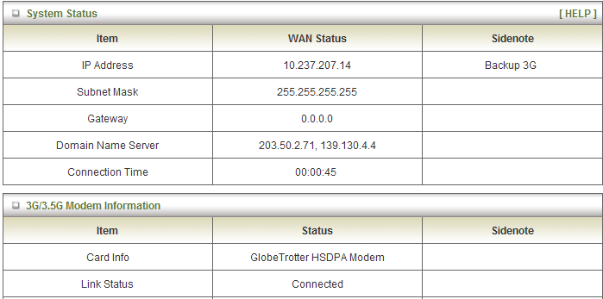

- When your primary (non-3G) WAN connection reconnects, the N3G005W will automatically revert to this connection. Please allow up to 2 minutes for this change to occur.

- To confirm that the process in Step 8 is complete, refresh the status page of the web interface after 1 minute. The WAN connection should appear as shown below:

